**Integrating Function of Non-Polynomial Nonlinearity**

**Case1: n=2**

mu=zeros(n,1)

P=[20.5058 69.2898

69.2898 234.3919]

[F=@(x)(sqrt(1+sum(x.^2,2)).^(-3))](mailto:F=@(x)(sqrt(1+sum(x.%5e2,2)).%5e(-3)))

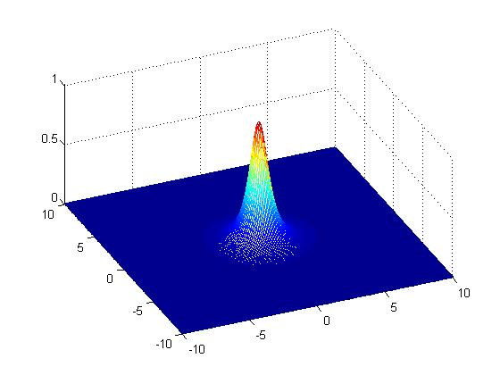

m_mc=sum(w.*F(x));

|  |  |  |  |  |  |
| --- | --- | --- | --- | --- | --- |
| Method | MC | GH | CKF | UT | NM4 |
| Int val | 0.0487 | 0.1008 | 0.0019 | 0.3340 | 0.3009 |
| %rel error | 51.6778 | 0 | 98.1292 | 231.4499 | 198.6130 |
| No. pts | 10^6 | 1D=155 | 4 | 4 | 8 |

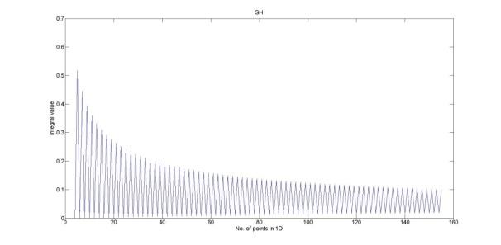

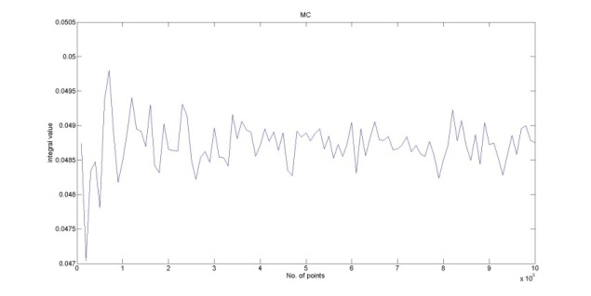

**Case2:**

mu=3*ones(n,1)

P=[20.5058 69.2898

69.2898 234.3919]

[F=@(x)(sqrt(1+sum(x.^2,2)).^(-3))](mailto:F=@(x)(sqrt(1+sum(x.%5e2,2)).%5e(-3)))

|  |  |  |  |  |  |
| --- | --- | --- | --- | --- | --- |
| Method | MC | GH | CKF | UT | NM4 |
| Int val | 0.0094 | 0.0108 | 0.0067 | 0.0059 | 0.0065 |
| %rel error | 12.7709 | 0 | 37.9849 | 45.6358 | 39.8393 |
| No. pts | 10^6 | 1D=155 | 4 | 4 | 8 |

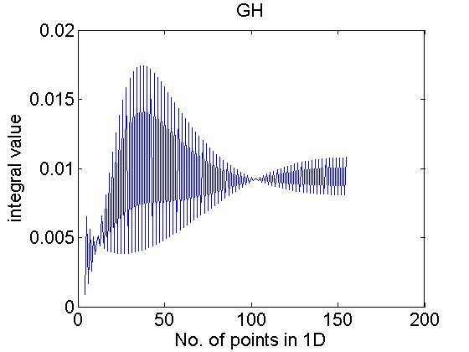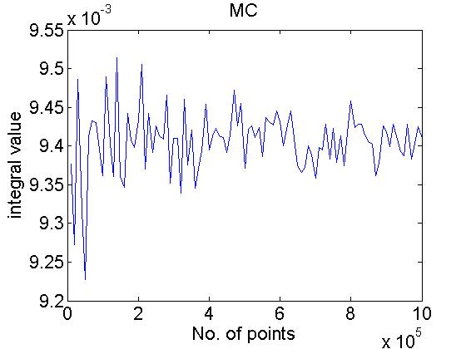

**Case3:**

mu=10*ones(n,1)

P=[20.5058 69.2898

69.2898 234.3919]

[F=@(x)(sqrt(1+sum(x.^2,2)).^(-3))](mailto:F=@(x)(sqrt(1+sum(x.%5e2,2)).%5e(-3)))

|  |  |  |  |  |  |
| --- | --- | --- | --- | --- | --- |
| Method | MC | GH | CKF | UT | NM4 |
| Int val*1e-3 | 0.7415 | 0.7417 | 0.5480 | 0.5017 | 0.4701 |
| %rel error | 0.0366 | 0 | 26.1135 | 32.3623 | 36.6241 |
| No. pts | 10^6 | 1D=155 | 4 | 4 | 8 |

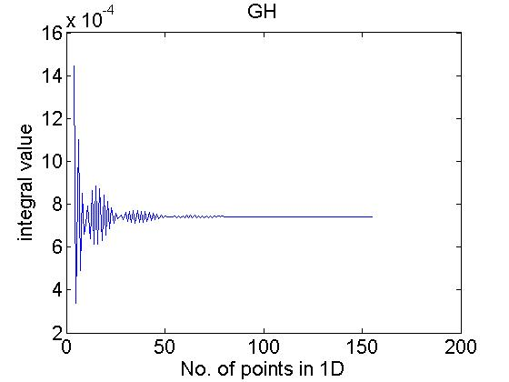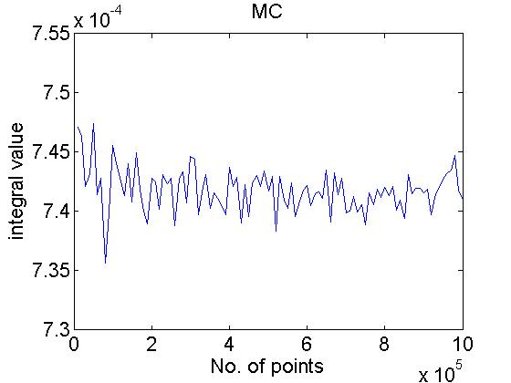

**Case4:**

mu=zeros(n,1)

P=eye(n);

[F=@(x)(sqrt(1+sum(x.^2,2)).^(-3))](mailto:F=@(x)(sqrt(1+sum(x.%5e2,2)).%5e(-3)))

|  |  |  |  |  |  |
| --- | --- | --- | --- | --- | --- |
| Method | MC | GH | CKF | UT | NM4 |
| Int val | 0.3438 | 0.3443 | 0.1925 | 0.4167 | 0.4048 |
| %rel error | 0.1546 | 0 | 44.1073 | 21.0113 | 17.5584 |
| No. pts | 10^6 | 1D=155 | 4 | 4 | 8 |

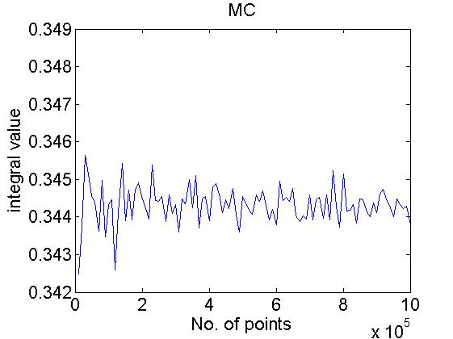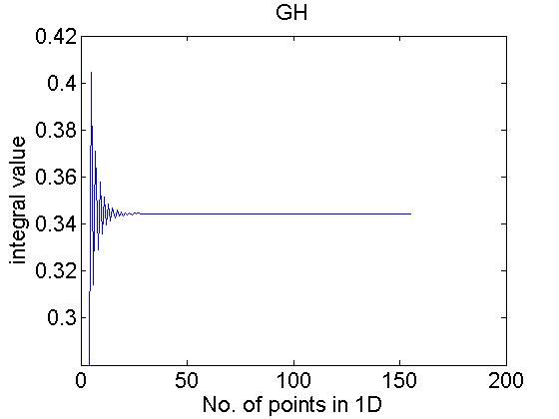

**Case5:**

mu=zeros(n,1)

P=10*eye(n);

[F=@(x)(sqrt(1+sum(x.^2,2)).^(-3))](mailto:F=@(x)(sqrt(1+sum(x.%5e2,2)).%5e(-3)))

|  |  |  |  |  |  |
| --- | --- | --- | --- | --- | --- |
| Method | MC | GH | CKF | UT | NM4 |
| Int val | 0.0689 | 0.0688 | 0.0104 | 0.3372 | 0.3052 |
| %rel error | 0.0409 | 0 | 84.9046 | 389.8410 | 343.3643 |
| No. pts | 10^6 | 1D=155 | 4 | 4 | 8 |

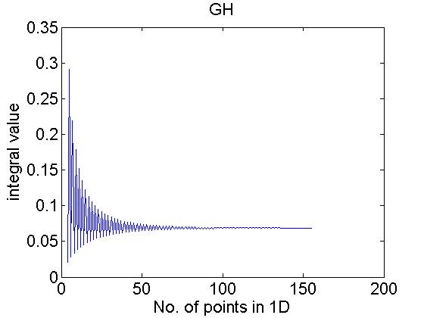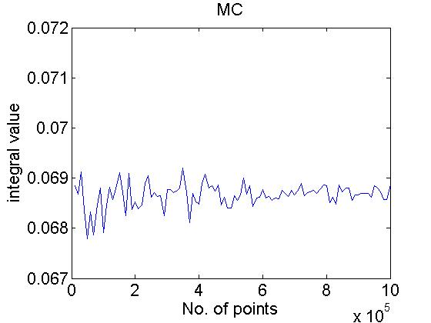

**Case6:**

mu=3*ones(n,1)

P=10*eye(n);

[F=@(x)(sqrt(1+sum(x.^2,2)).^(-3))](mailto:F=@(x)(sqrt(1+sum(x.%5e2,2)).%5e(-3)))

|  |  |  |  |  |  |
| --- | --- | --- | --- | --- | --- |
| Method | MC | GH | CKF | UT | NM4 |
| Int val | 0.0332 | 0.0333 | 0.0127 | 0.0096 | 0.0107 |
| %rel error | 0.1856 | 0 | 61.7578 | 71.0798 | 67.8272 |
| No. pts | 10^6 | 1D=155 | 4 | 4 | 8 |

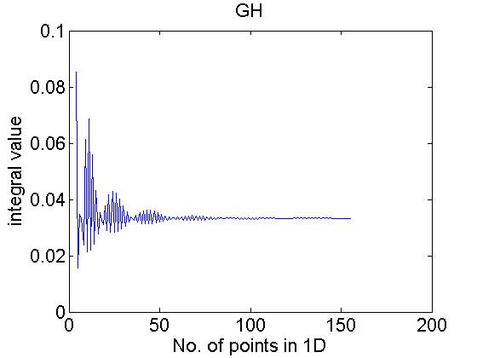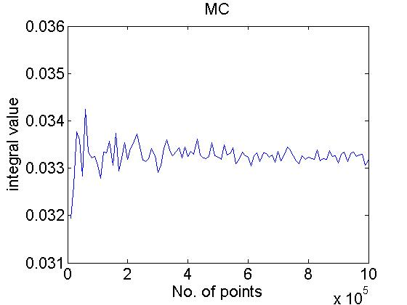

**Case7:**

mu=zeros(n,1)

P=eye(n);

[F=@(x)(sqrt(1+sum(x.^2,2)).^(3))](mailto:F=@(x)(sqrt(1+sum(x.%5e2,2)).%5e(3)))

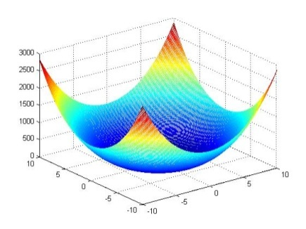

|  |  |  |  |  |  |
| --- | --- | --- | --- | --- | --- |
| Method | MC | GH | CKF | UT | NM4 |
| Int val | 5.9634 | 5.9670 | 5.1962 | 5.6667 | 5.9532 |
| %rel error | 0.0604 | 0 | 12.9191 | 5.0339 | 0.2318 |
| No. pts | 10^6 | 1D=155 | 4 | 4 | 8 |

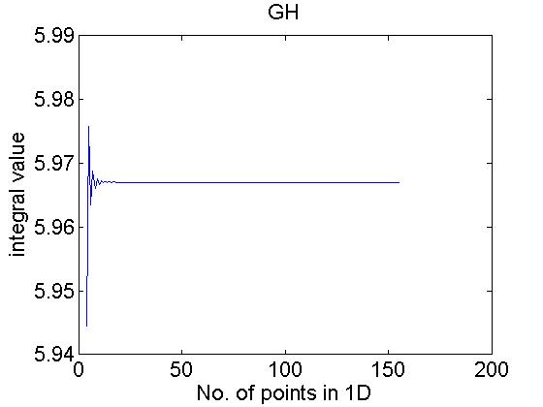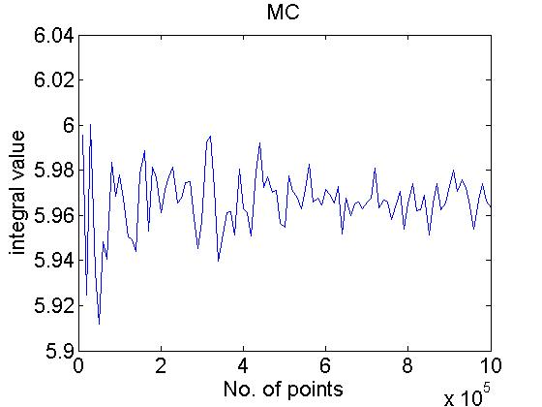

**Case8:**

mu=zeros(n,1)

P=100*eye(n);

[F=@(x)(sqrt(1+sum(x.^2,2)).^(3))](mailto:F=@(x)(sqrt(1+sum(x.%5e2,2)).%5e(3)))



|  |  |  |  |  |  |
| --- | --- | --- | --- | --- | --- |
| Method | MC | GH | CKF | UT | NM4 |
| Int val*1e3 | 3.7789 | 3.7788 | 2.8497 | 3.4818 | 3.7855 |
| %rel error | 0.0039 | 0 | 24.5878 | 7.8602 | 0.1774 |
| No. pts | 10^6 | 1D=155 | 4 | 4 | 8 |

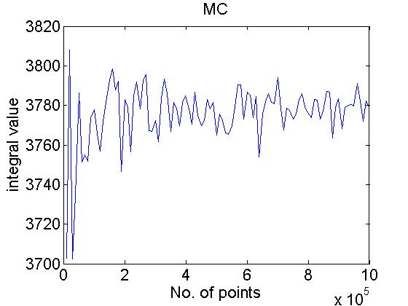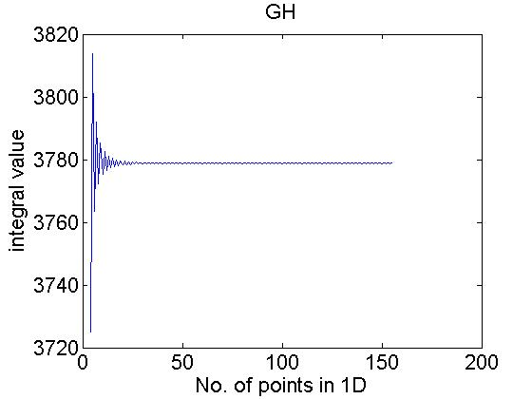

**Polar to Cartesian Coordinates**

sigr=(0.02)^2;

sigth=(15)^2;

mur=1;

muth=90;

F=@(x)([x(:,1).*cosd(x(:,2)),x(:,1).*sind(x(:,2))]);

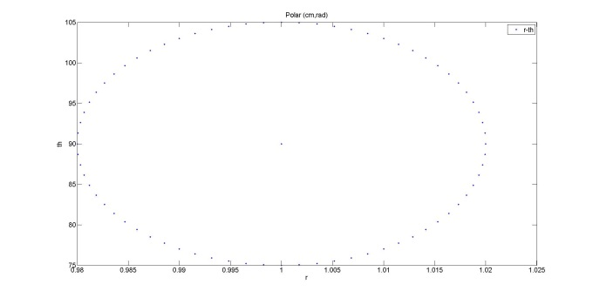 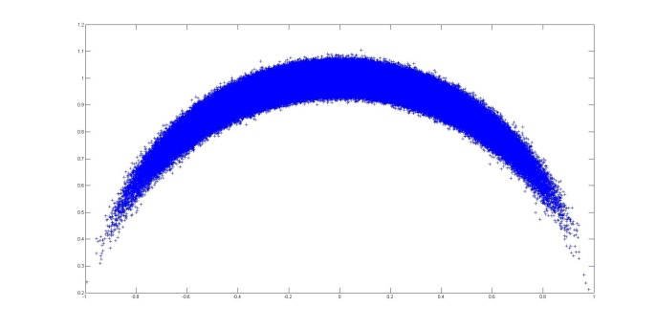 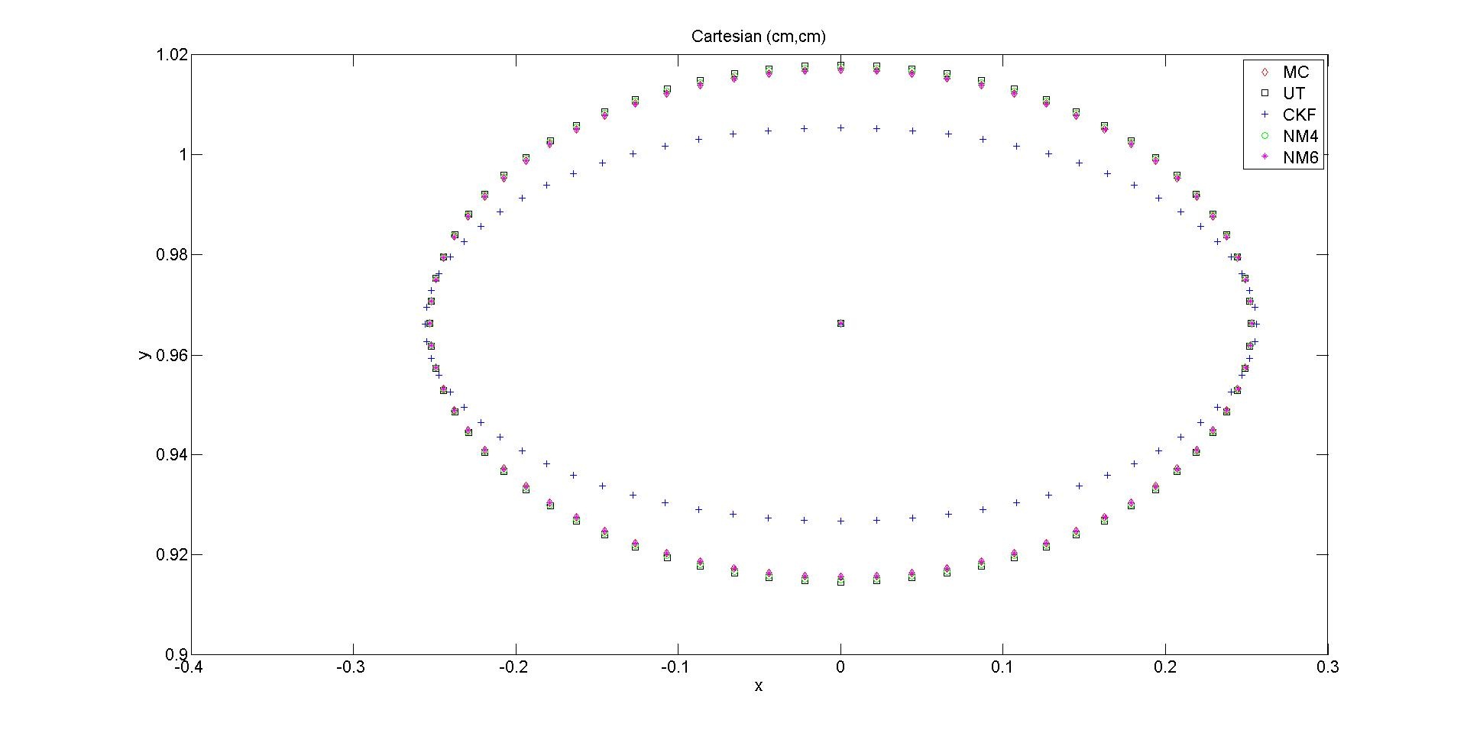

|  |  |
| --- | --- |
| **mu_mc** | **-0.0001 0.9663** |
| **mu_ut** | **0 0.9663** |
| **mu_ckf** | **0 0.9661** |
| **mu_nm4** | **0 0.9663** |
| **mu_nm6** | **-0.0000 0.9663** |

sigr=(2)^2;

sigth=(15)^2;

mur=1;

muth=90;

[F=@(x)([x(:,1).*cosd(x(:,2)),x(:,1).*sind(x(:,2))])](mailto:F=@(x)([x(:,1).*cosd(x(:,2)),x(:,1).*sind(x(:,2))]));

Evaluating the expected integral

$$μ=E\left[\left(\begin{matrix}x \\ y\end{matrix}\right)\right]=\iint{\left[\begin{matrix}rcos\left(θ\right) \\ rsin\left(θ\right)\end{matrix}\right]}N(μ_{r},μ_{θ}|σ_{r},σ_{θ})drdθ$$

$$P=E\left[\left(\begin{matrix}x \\ y\end{matrix}\right)\right]=\iint{\left[\begin{matrix}rcos\left(θ\right) \\ rsin\left(θ\right)\end{matrix}\right]}\left[\begin{matrix}rcos\left(θ\right) & rsin\left(θ\right)\end{matrix}\right]N\left(μ_{r},μ_{θ} | σ_{r},σ_{θ}\right)drdθ-μ$$

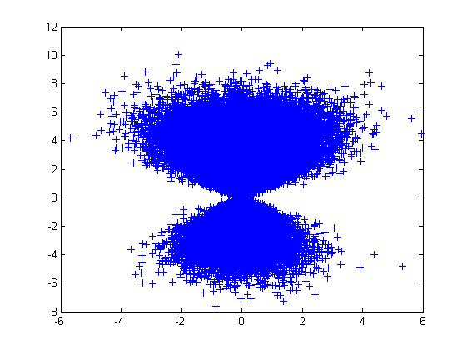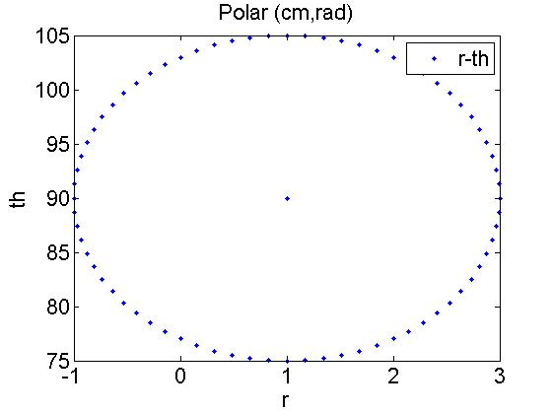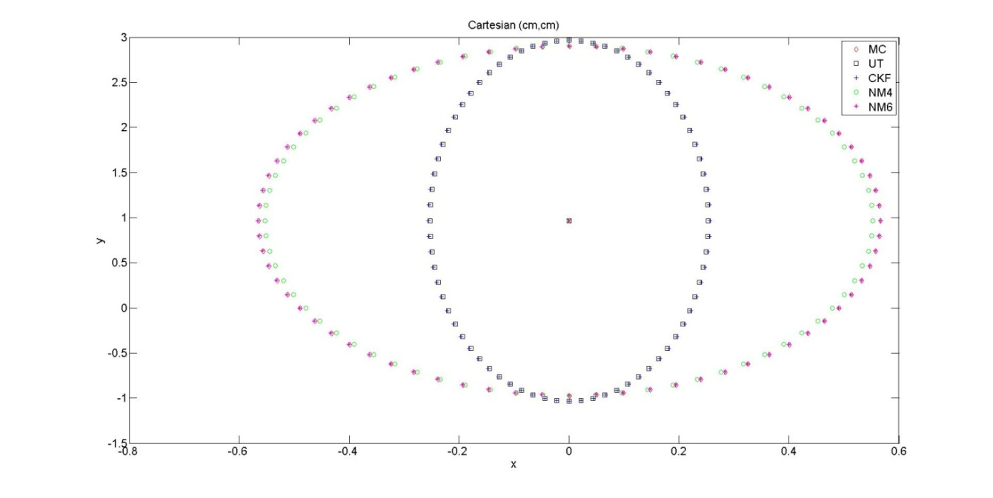

|  |  |
| --- | --- |
| **mu_mc** | **0.0001 0.9677** |
| **mu_ut** | **0 0.9663** |
| **mu_ckf** | **0 0.9661** |
| **mu_nm4** | **-0.0000 0.9663** |
| **mu_nm6** | **0 0.9663** |